**Table of Contents**

**Table of Contents 1**

**1. Introduction 3**

1.1 Purpose 3

1.2 Scope 3

1.3 Definition, acronyms and abbreviations 3

1.4 References 4

1.5 Overview 4

**2. Overall Description 5**

2.1 Product Perspective 5

2.2 Product Functions 5

2.3 User Classes and Characteristics 6

2.4 Operating Environment 6

**3. Specific Requirements 8**

3.1 User interfaces 8

3.2 System boundary 13

3.3 Functional requirements 14

3.3.1 User Class 1 – The Customer 14

3.3.2 User Class 2 – The Accountant 15

3.3.3 User Class 3 – The Shop owner 16

3.3.4 User Class 4 – The Software owner 17

3.4 Performance requirements 18

3.4.1 Response time 18

3.4.2 System dependability 18

3.5 Design constraints 19

3.5.1 Standard Development Tools 19

3.5.2 Web based service 19

3.5.3 Online user documentation 19

3.6 Non-functional Requirements 19

3.6.1 Security 19

3.6.2 Reliability 20

3.6.3 Availability 20

3.6.4 Maintainability 20

3.6.5 Portability 20

**4. Prioritization & Release Plan 21**

4.1Choice of prioritization method 21

4.2 Release Plan 21

1. **Introduction**

This section gives a scope description and overview of everything included in this SRS document. Also, the purpose for this document is described and a list of abbreviations is provided.

* 1. **Purpose**

The purpose of this document is to give a detailed description of the requirements for the “E-Receipt” software. It will illustrate the purpose and complete declaration for the development of system.

It will also explain system constraints, interface and interactions with other external applications. This document is primarily intended to be proposed to a customer for its approval and a reference for developing the first version of the system for the development team.

* 1. **Scope**

The “E-Receipt” is an email based application which helps people to get their receipt via email or SMS. In this receipt Customer gets all the details they get in their regular receipt after the payment. It also helps Customers to check all their payment details anytime.

Shop owners analyze information using this software. They can check and observe their sell details to improve their services in order to fulfill Customer demands. They will also be able to offer various services to their regular Customers. The software owner will be able to collect data from this software and he may use this data to his business purpose.

Furthermore, the software needs Internet connection to send and view the receipt. All system information is maintained in a database, which is located on a web-server.

* 1. **Definition, acronyms and abbreviations**

|  |  |
| --- | --- |
| **Term** | **Definition** |
| Customer | Someone who will buy products and get the “E-Receipt” |
| Accountant | Someone who will Provide the service of sending “E-Receipt” and open account for customer if needed. |
| Shop Owner | Someone who has a shop and wants to be a part of this system |
| Software Owner | Owner of the Software |
| FR | Functional Requirements |
| DESC | Description |
| OS | Operating System |
| Stakeholder | Any person who has interaction with the system who is not a developer |
| METER | The process or device used to establish location on a SCALE contained in a PLanguage statement |
| MUST | The minimum level required to avoid failure contained in a PLanguage statement |
| QR | Quality Requirement |
| WISH | A desirable level of achievement that may not be attainable through available means contained in a PLanguage statement |

* 1. **References**

[1]IEEE Software Engineering Standards Committee, “IEEE Std 830-1998, IEEE Recommended Practice for Software Requirements Specifications”, October 20, 1998

* 1. **Overview**

The reminder of this document includes four chapter. The second one provides an overview of the system functionality and system interaction with other systems. This chapter also introduces different type of stakeholders and their interaction with the system. Further, the chapter also mentions the system constrains of the product.

The third chapter provides the requirements specification in detailed terms and a description of the different system interfaces. Different specification techniques are used in order to specify the requirements more precisely for different audiences. This chapter also includes system boundaries.

The fourth chapter deals with the prioritization of the requirements. It includes a motivation for the chosen prioritization methods and discusses.

**2. Overall Description:**

This section will give an overview of the whole system. The system will be explained in its context to show how the system interacts with other systems and introduce the basic functionality of it. It will also describe what type of stakeholders that will use the system and what functionality is available for each type. At last, the constraints and assumptions for the system will be presented.

**2.1 Product perspective**

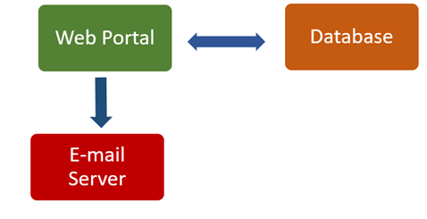

Fig 1- Block Diagram

This system will consist of two parts: Web portal and E-mail server. The e-mail server will be used to send e-receipt to the customer while the web portal will be used for managing the information about the receipt and the system as whole.

The web portal will take the data from the users. Then it has to communicate with the e-mail server to send some specific data. E-mail server will show the relevant data to the users.

Since this is a data-centric product it will need somewhere to store the data. For that, a database will be used. Web portal will communicate with the database. Web portal will add and modify data. All of the database communication will go over the Internet.

**2.2 Product functions**

A first-time user of the software should see the homepage of E-receipt. If the user has not registered, he/she should have to sign up to use the system. Each user after signing up the form they will get a confirmation email to confirm their signup process with a link. After that they have to click on the confirmation link to complete signup process. After signup if a customer signs in the system, he will get an interface. He will be able to check his purchase history. If an accountant login to the system he will get an interface, where he/she will input customer information in order to register them and send the E-receipt. If a shop owner login to the system, then an interface will have appeared. He will be able to check sell history by date, top sold products and customer info with purchase details. If company owner login to the system, then he/she will be able to view his clients (company) list with number of customers and also he will be able to view customer info with purchase history. Besides he will be able to download all these data as PDF. Accountants send the receipt to the customers through e-mail and store data to the database.

**2.3 User characteristics**

There are four types of users that interact with the system: software owner, shop owners, accountants and the customers. Each of these four types of users has different use of the system so each of them has their own requirements.

The customers can only use the system to view their shopping history. This means that the customers have to be able to login in to their accounts. They need to be able to access the relevant pages. In order to use this system, customer have to sign up by his own or he have to be registered by the shop accountant. He has to provide his name, phone number and email to be registered.

The shop owners will not use the mail server but the list of the whole data instead. There they will manage the information about their selling products. They can get information that which accountant sells which products, which products are more popular to their customers and they can calculate their daily profits. To use this system, the company or the shop owner should be registered to the system by clicking “click here to signup” link. And he/ she have to provide Name, username, shop category, phone, Shop name, shop ID, E-mail, shop address and password.

The accountants interact with the mail server and the database. They are managing the overall system so there is no incorrect information within it. The accountants can manage the receipt for each customer and collecting data to the database for the shop owners. To use this system, the accountant should be registered to the system. He/ she have to click to signup link and should have select “Signup as Accountant” option to fill up the form. He has to provide Name, Username, Phone, Email, and Password and shop ID to get registered. A mail will be automatically sent to the shop owner to confirm. If shop owner accepts the request, then the accountant will be registered.

Software owner will be able to login to the system with username and password. The software owner will be able to view clients (Company list) where Company name and Number of customer will be displayed. The Software owner will be able to view customer info with purchase history. Software owner will be able to download all data as PDF.

**2.4 Constraints**

Electricity is a constraint for the system. It the electricity will be disconnected at time of sending receipt, the receipt can’t be delivered instantly. It will take time. Sometimes data can be lost .

The Internet connection is also a constraint for the system. Since the system fetches data from the database over the Internet, it is crucial that there is an Internet connection for the application to function.

Both the web portal and mail server will be constrained by the capacity of the database. Since the database is shared between both applications it may be forced to queue incoming requests and therefor increase the time it takes to fetch data.

**3. Specific Requirements**

This section contains all the functional quality of the system. It gives a detailed description of the system and all its features.

**3.1 User interfaces**

This section provides basic prototypes of the user interface.

A first-time user of the software should see the homepage of E-receipt, as Figure 1. A user could be a general customer or accountant (Cash counter) or could be a Shop owner. If the user has not registered, he/she should have to sign up to use the system.

A general customer have to sign up as Customer by clicking “click here to sign up” as shown on figure 1. After clicking there a new page will come up as shown in figure 2. He/she have to fill up the form properly.

If the customer is an accountant (Counter cashier of a shop). Then he have to select “signup as Accountant” option as shown in figure 3.

If the user is a shop owner then he have to select “sign up as shop owner” option to register as shown on figure 4. He have to fill up the form to sign up.

Each user after signing up the form they will get a confirmation email to confirm their signup process with a link. After that they have to click on the confirmation link to complete signup process.

After signup if a customer sign in the system, he will get an interface as shown in figure 5. He will be able to check his purchase history.

If an accountant login to the system he will get an interface as shown in figure 6, where he/she will input customer information with purchase details in order to register them and send E-receipt.

If a shop owner login to the system then an interface will appeared as shown in figure 7. He will be able to check sell history by date, top sold products and customer info with purchase details.

If Software owner login to the system then he/she will be able to view his clients (company) list with number of customers and also he will be able to view customer info with purchase history. Besides he will be able to download all those data as PDF as shown in figure 8.

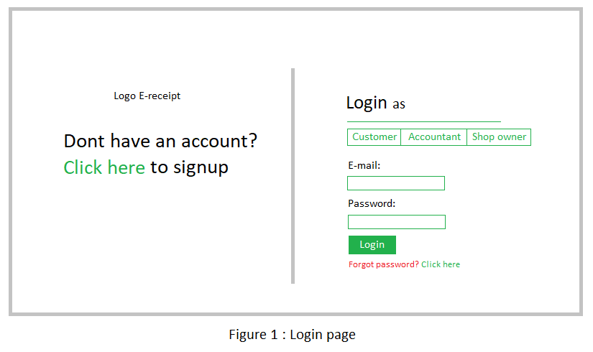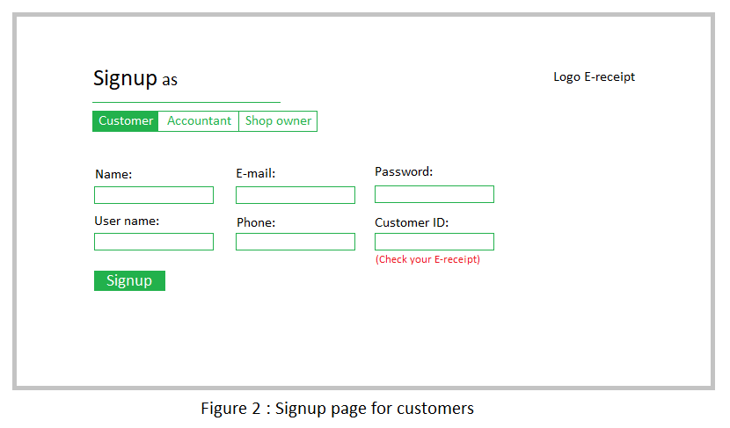

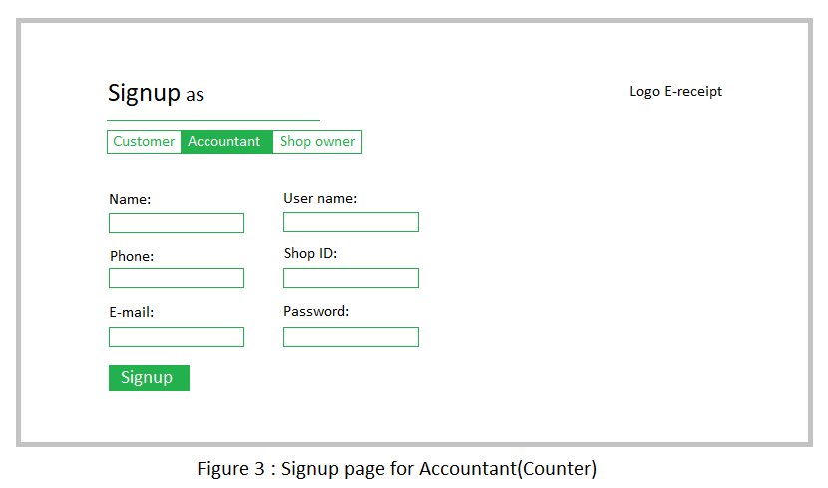

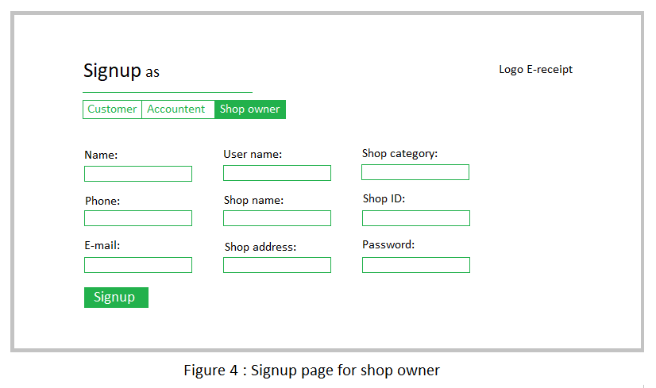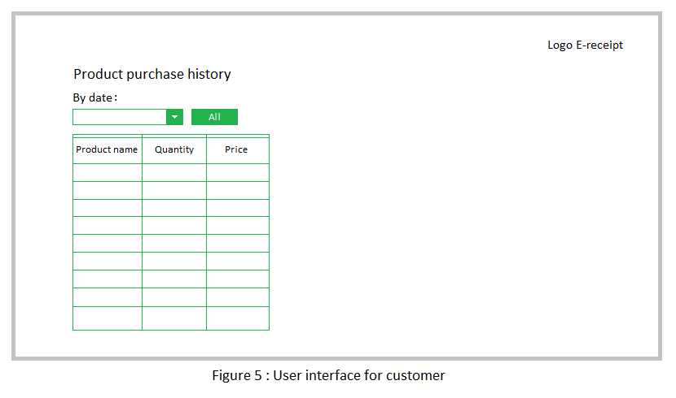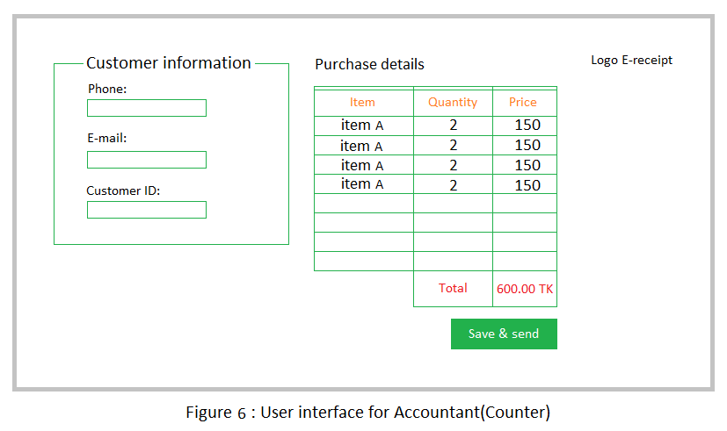

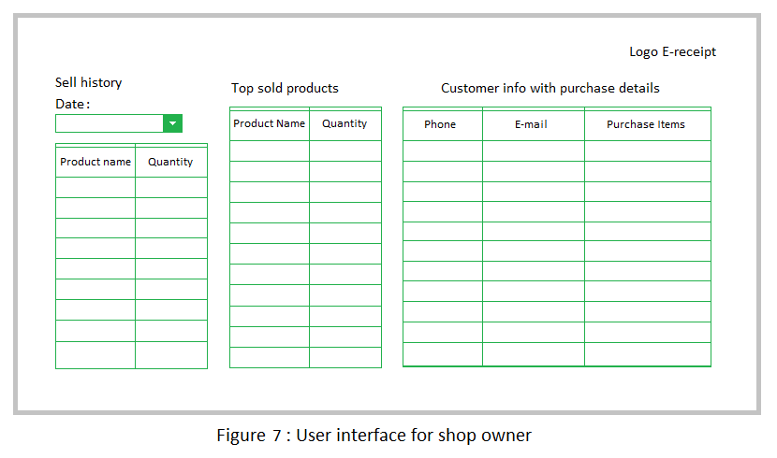

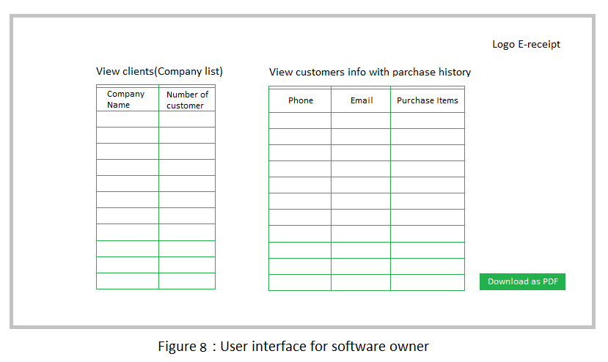

**3.2 System boundary**

Shop owner

Accountant (Counter cashier)

Customer

Software owner

**3.3 Functional requirements**

This section includes the requirements that specify all the fundamental actions of the software system.

**3.3.1 User Class 1 – The Customer**

**3.3.1.1 Functional requirement 1.1**

**ID: FR1**

Title: Signup

DESC: In order to view purchase history customer have to sign up. He have to provide his name, phone number and email and the Customer ID (Provided by the shop accountant through mail and SMS) to get registered.

He/ she must have to provide the same email address and phone number which He/ she had given to the shop accountant.

**3.3.1.2 Functional requirement 1.2**

**ID: FR2**

Title: Login

DESC: To login to the system user have to go to the system website and he/she have to select “Login as customer” option and have to provide email and password to get access.

**3.3.1.3 Functional requirement 1.3**

**ID: FR3**

Title: View purchase history

DESC: Customer will be able to view his product purchase history by login to the system. He/ She will be able to view history by date by selecting date from the dropdown menu or he/ she can view all history by clicking “All” button.

**3.3.1.4 Functional requirement 1.4**

**ID: FR4**

Title: Retrieve password

DESC: User will be able to retrieve password by clicking “forgot password” link on home page. An email have to be sent with a password reset link to the user to retrieve password.

**3.3.2 User Class 2 – The Accountant (Counter cashier)**

**3.3.2.1 Functional requirement 2.1**

**ID: FR5**

Title: Signup

DESC: To use this system the accountant should be registered to the system. He/ she have to click on signup link and should have select “Signup as Accountant” option to fill up the form. He have to provide Name, Username, Phone, Email, and Password and shop ID to get registered. A mail will be automatically sent to the shop owner to confirm. If shop owner accept the request then the accountant will be registered and will get a confirmation email.

**3.3.2.2 Functional requirement 2.2**

**ID: FR6**

Title: Login

DESC: An accountant will be able to login if he/ she register successfully.

**3.3.2.3 Functional requirement 2.3**

**ID: FR7**

Title: Register customer

DESC: Accountant will be able to register customers. To register a customer he have to input phone and email of the customer. A customer ID will be automatically generated.

**3.3.2.4 Functional requirement 2.4**

**ID: FR8**

Title: Input items

DESC: Accountant will input the product name with quantity and price of items of customer desired products. Total price will be automatically generated.

**3.3.2.5 Functional requirement 2.5**

**ID: FR9**

Title: Save Items

DESC: Accountant should be able to save items to database by clicking “save and send” button.

**3.3.2.6 Functional requirement 2.6**

**ID: FR10**

Title: Send receipt to the customer’s email and phone

DESC: If the receipt is ready then Accountant have to click “save and send” button to save and send the receipt to the customer’s mail address and phone number.

**3.3.2.7 Functional requirement 2.7**

**ID: FR11**

Title: Retrieve password

DESC: Accountant will be able to retrieve his password if he/ she forgot password.

**3.3.3 User Class 3 – The Shop owner**

**3.3.3.1 Functional requirement 3.1**

**ID: FR12**

Title: Signup

DESC: To use this system the company or the shop owner should be registered to the system by clicking “click here to signup” link. He have to choose “Signup as Shop owner “option to get sign up. And he/ she have to provide Name, username, shop category, phone, Shop name, shop ID, E-mail, shop address and password. After providing information he will get an email with a confirmation link to complete signup process.

**3.3.3.2 Functional requirement 3.2**

**ID: FR13**

Title: Login

DESC: If the shop owner is registered then he will be able to login to the system.

**3.3.3.3 Functional requirement 3.3**

**ID: FR14**

Title: View sell history

DESC: Shop owner will be able to view sell history by date by select the date from the dropdown menu.

**3.3.3.4 Functional requirement 3.4**

**ID: FR15**

Title: View top sold products

DESC: Shop owner will be able to view top sold products.

**3.3.3.5 Functional requirement 3.5**

**ID: FR16**

Title: View customer info with purchase details

DESC: Shop owner will be able to view customer info with purchase item list.

**3.3.3.6 Functional requirement 3.6**

**ID: FR17**

Title: Retrieve password

DESC: Shop owner will be able to retrieve password if he forgot by clicking “forgot password” link. An email will become sent to the user with a reset link.

**3.3.4 User Class 4 – The Software owner**

**3.3.4.1 Functional requirement 4.1**

**ID: FR18**

Title: Login

DESC: Shop owner will be able to login to the system with username and password.

**3.3.4.2 Functional requirement 4.2**

**ID: FR19**

Title: View clients (Company list) with number of customers

DESC: Shop owner will be able to view clients (Company list) where Company name and Number of customer will be displayed.

**3.3.4.3 Functional requirement 4.3**

**ID: FR20**

Title: View customers info with purchase history

DESC: Software owner will be able to view customer info with purchase history.

**3.3.4.4 Functional requirement 4.4**

**ID: FR21**

Title: Download all data as PDF

DESC: Software owner will be able to download all data as PDF. He/ She have to click “Download as PDF” button to download data as PDF.

**3.4 Performance requirements**

The product shall be based on web and has to be run from a web server. The product shall take initial load time depending on internet connection strength which also depends on the media from which the product is run. The performance shall depend upon hardware components of the client/customer. Must resolve locking issues and handle concurrent use of the system on a 24x7 basis.

The system shall automatically log out all customers after a period of inactivity. The system shall not leave any cookies on the customer’s computer containing the user’s password and confidential information.

**3.4.1 Response time**

ID: QR1

TITLE: The response time of a send button.

DESCRIPTION: The response time of a search is the overall time beginning with the initial user action (click on the send button) on the web device, the request going to server, the response received from the server, and finally the response processing by the web application.

METER: Measurements obtained from 1000 entries during testing (Laravel 5.0).

MUST: No more than 2 seconds during 100% of the sending E-Receipt during testing.

WISH: No more than 1 second during 100% of the sending E-Receipt during testing.

**3.4.2 System dependability**

ID: QR2

TITLE: System Dependability.

DESCRIPTION: If the system loses the connection to the Internet or the system gets some strange input, the user should be informed.

METER: Measurements obtained from 1000 hours of usage during testing.

MUST: 100% of the time.

The system shall maintain customer email information as a required part of customer profile.

The system shall send receipt to the user through email.

**3.5 Design constraints:**

Design constrains are described below.

**3.5.1 Standard Development Tools**

The system shall be built using a standard web page development tool. Implement the database at least using a centralized database management system. All coding will be done in HTML, CSS and LARAVEL 5.0 (PHP framework).

**3.5.2 Web based service**

There are no memory requirements. The computers must be equipped with web browsers such as Internet explorer, Mozilla Firefox or Google chrome etc.

Developers should use common libraries and tools that can work with all the common internet browser application with no problem.

The product must be stored in such a way that allows the client easy access to it. Response time for loading the service should take no longer than two seconds. A general knowledge of basic computer skills is required to use the service.

All user data will be kept on cloud server and necessary precautions should be taken to protect user data.

**3.5.3 Online user documentation**

As the product is E-Receipt, On-line help system becomes a critical component of the system which shall provide –

It shall provide specific guidelines to a user for using the E-mail system and within the system. To implement online user help, link and access receipt storage shall be provided.

**3.6 Non-functional Requirements**

Nonfunctional requirements are described below.

**3.6.1 Security:**

The system will have a secured database to store all relevant data. The system will automatically log out all customers after a period of inactivity (for example: 20 minutes). The system won’t leave any cookies on the customer’s account containing the user’s password or something like that. The system’s back-end servers will only be accessible to germane administrators. Sensitive data will be encrypted before being sent over insecure connections like the internet.

**3.6.2 Reliability:**

The reliability of the overall program depends on the reliability of the separate components. The main pillar of reliability of the system is the backup of the database which is continuously maintained and updated to reflect the most recent changes. And this is present totally in this project. Again searching for the particular data will be accurate and served as fast as possible.

**3.6.3 Availability:**

The system will be available at all times, meaning the user can access it (available email in individuals’ account) using a web browser, only restricted by the down time of the server on which the system runs. In case of a hardware failure or database corruption, a replacement page will be shown. Also in case of a hardware failure or database corruption, backups of the database should be retrieved from the server and saved by the administrator. Then the service will be restarted i.e. 24 X 7 availability!

**3.6.4 Maintainability:**

A commercial database will be used for maintaining the database and the application server takes care of the site. In case of a failure, a re-initialization of the program will be done. Also the software design is being done with modularity so that maintainability can be done efficiently.

**3.6.5 Portability:**

The application is HTML and server language (PHP) based. So the end-user part is fully portable and any system using any web browser should be able to use the features of the system. Also any hardware platform will be available in the future. Again, the team is also thinking about mobile application of this system. Up to this now, the system can run on any OS; either it is Windows or Linux. The system shall run on PC, Laptops etc.

**4. Prioritization & Release Plan**

**4.1 Choice of prioritization method:**

Our group is usually able to generate a list of goals and actions very easily. But after our meetings, we find that we are over our heads with too much extra work. We found that In “E-Receipt” Nominal prioritization is the best way to prioritization. At first, we discuss the nominal prioritization.

|  |  |
| --- | --- |
| ***Names*** | ***Meanings*** |
| *High*  *Medium*  *Low* | a mission critical requirement; required for next release  supports necessary system operations; required eventually but could wait until a later release if necessary  a functional or quality enhancement; would be nice to have someday if resources permit |
| *Essential*  *Conditional*  *Optional* | the product is not acceptable unless these requirements are satisfied  would enhance the product, but the product is not unacceptable if absent  functions that may or may not be worthwhile |

**4.2 Release Plan**

A Release Plan is a medium term plan that defines a series of high level goals that delivery teams can "sprint" or "flow" towards. Release plans join up the program views with Projects/Delivery Teams. Each Release is typically defined iteratively in terms of scope as a subset of a Backlog. We recommend releases are defined in terms of Integration Scenarios or Features, or other elements from a Scoping Diagram etc.

In our “E-Receipt” project the requirements were divided into three releases based on the prioritization and their dependencies.

1. At first release the requirements that build up the foundation of the application were included and highly prioritized requirements and their dependencies

2. The second release includes important requirements. It create the additional features that making the software product more effective.

3. The third release includes the requirements that can be discarded if the project gets delayed.